April Newsletter
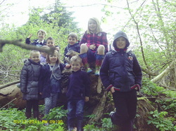
The Easter Holidays have arrived and we have had such a fun holiday club, and thankfully been blessed with some good weather too. We have had a great first week of the holidays, and done so many fun activities including Getting down and dirty, Fishing, Nature trails, Arts and crafts, Pizza and Quiche making, Movies, sports and team games to name but a few, Please have a look at our picture links to see how much fun all the children have had.

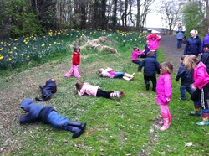

Getting down and dirty
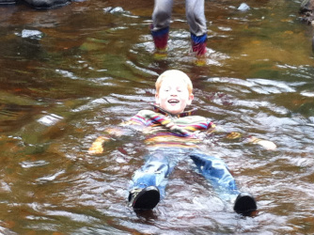
As you can see by all the photo's the children really enjoyed playing in the mud, some even braved it and went for a full body paddle in the river. All these types of activities the children really get some much out of, as well as having a great time and a great laugh, they also learn some basic survival skills, and team building skills, as the older children really help the younger ones enjoy the full experience of risk and challenge activities. All these activities are lead by the children, but at all times have full adult supervision, although we do not get involved in their play experience unless they invite us to join in, which we are so grateful that they do, as it gives us all a chance to be a big kid ourselves again.

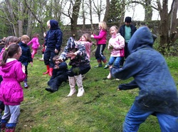
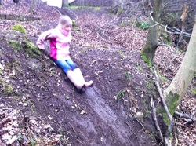

You've got a friend in me
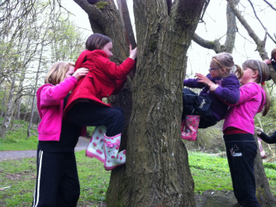
The children just love being in the great outdoors, and it is amazing how much fun and laughter they have playing with the natural environment which surrounds them, who thought climbing a tree would be such fun. Even the younger children cant resist giving it a try, but with fantastic helpers on hand, this is no problem. We really like to encourage the children to participate in all the play opportunities the staff create, and once they have given it a go there is just no stopping them.

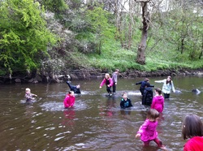

Gok Whan meet our mok Whan fashion designers
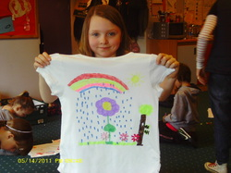
Leaving the children with a table full or resourses to get creative is such a joy to watch, the children take so much time and put so much effort into what they are doing, and as a staff team, we have to say that we are just amazed at their final creations, in fact im sure we would wear their designs. Im sure there will be a full children in the near future that could be the next Armani or Vivian Westwood.

More News
We have recently welcomed Lucy Smith to our team, and i can say that Lucy is just having a great time getting involved in everything the club has to offer. Anyone who has not yet met or been introduced to Lucy, please pop in and say hello.
As you are all aware the annual registration and sibbling forms are now being handed out, or you can print off you own forms from the website, please note that all the forms must be returned and signed for in the club no later than the 28th of April.
Other up and coming holiday clubs, on the 2nd of May as it is a public holiday we can not get access into the school. the children who are booked into the club on this day, must be dropped off by 9am at the swing park at the school, from there we are heading on an adventure to Polkemmet counrty park, Lunch and snacks will need to be provided by the parents/carers for this day, and also a change of clothes and wellies will need to be packed too. We will be back at the school swing park for 5pm where children can then be collected.
The 5th of May all children who are booked in must be dropped of in the car park at Mill farm for 8.20am, where we will get on a private coach up to Beecraigs counrty park, again lunch and snacks must be provided this day. The bus will return us to the farm for 1pm, where the children will then spend the rest of the afternoon in the farm. Parents please note the all children must be collected by 5pm at the very latest this day, as this is when Mill farm closes. If you need any further information, or if you are unsure on any of the details, please just speak to Nikki for futher information.

Little Villagers - Livingston Village Out Of School Care Project

