August 2011 News
Well all i can say is what a fun packed summer, please eveyone go on and have a look at all the pictures on the website, and get a feel of what your child has got up to over the holidays, im sure you will agree it looks just fab!!!!

Summer fun
We had loads of fun activities on the go over the summer, these included BBQs, Arts, Trips to the cinema, farm and Gullane Beach, also water games, Sumo Fights, Risk and Challenging activities, fire building, den building, getting down and dirty, walks, nature trails and thats only to name a few, was just a great Summer, have to say all the staff and children were exhausted.
We also had our annual Care Commision (Social Services) inspection, and are pleased to say again that we were graded with 5's and 6's in the club, which all the staff are very proud of. This inspection report will be availible online soon, you can see it at www.carecommission.com.

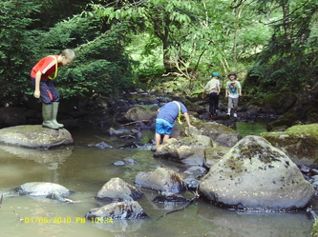
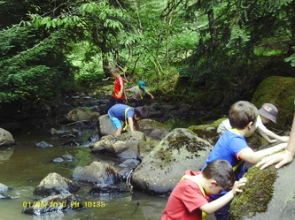

New Term
We have just started our new term, and have welcomed some new faces into the club. All the children have settled in well, and it is great to see all the old faces back, we are missing our P7's who left at the summer, and wish them lots of best wishes and good luck for the future.
We will soon be introducing Lisa to the breakfast club shifts, once we have her PVG form back, until then, Fiona will still be around to ensure all our ratio's are correct.
Here's to another fun packed term.
September Holiday club booking form is now also online, deadline is Friday the 9th of September. so please ensure all forms are returned by then.

Little Villagers - Livingston Village Out Of School Care Project

