Easter Holidays were just Fantastic!!
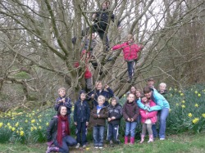
What a fantastic time we have had over the Easter period, Term time the children got involved in lots of Easter Crafts, including making their very own Easter Tree, i'm sure you will all agree it was Beautiful. Also it's been great to see the sunshine out and we have been making good use of our outdoor space where the children benifit from lots of locomotor and physical play, great to feel a wee bit heat on us after our long cold winter.

Easter Holidays
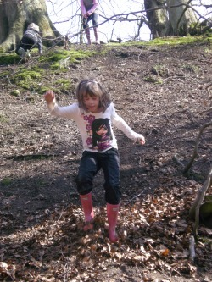
Our Easter Holiday club was a fantastic, we organised a wide range of fun and exciting activities, these included Baking, River Walking, Building Fires, Getting down and Dirty, Treasure Hunt, Trip to mill farm, Dance and Exercise,Crafts, Movies, Sports and many more, the feedback from the Children was great and it was nice to hear from the parent's how much their children have enjoyed themselves. All holiday club photo's have been uploaded and are under More Holiday Fun.

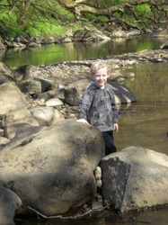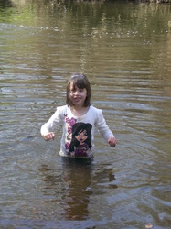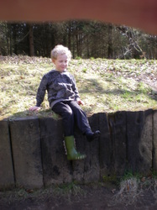

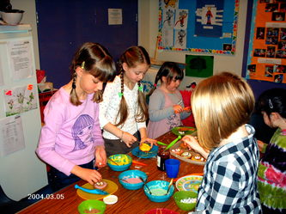

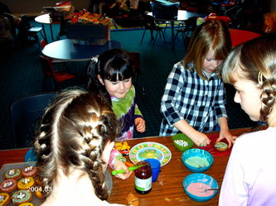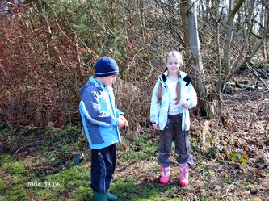

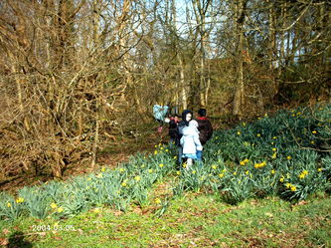

Other News
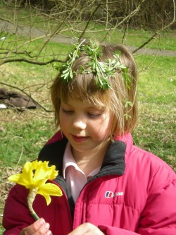
As you are all aware our A.G.M is fast approaching on the 11th of May at 7pm in the Community Room, would be lovely if parent's would come along, and also new parent's who are interested in registering their children, this is the time to do so. We look forward to seeing old and new faces.
Changes in our staff team will also be happening in the next couple of Months, Fiona Docherty, one of our playworkers will be leaving us at the end of May, Fiona has been offered a wonderful experience to become a staff member in Camp America, working with Special needs Children. Fiona will be missed but will return to help us out in Holiday clubs, when she returns for university in September.
We will be introducing 3 new staff members to the team, Cheryl, John and Karen, im sure they will love their time at The Little Villagers and all be an asset to our exsisting Team, Lorraine, Mary, Jillian and Myself.
We are all looking forward to the next few months, and hope to make all the children's time in the Little Villagers the best ever........................Here's to the Summer Holidays :)

