Happy New Year To You All
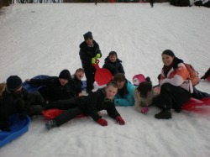
Happy New Year to all our user, and what a fun start to the year it has been, the weather has caused us all sorts of problems, but now there seems to be a thaw on all the Little Villagers decided to make the most of it and all got kitted out for an afternoon sledging,and what fun it was, please check out all the picture that have been uploaded. Everyone had a blast including the adults, as you can see by the photos, a great day was had by all, and everyone was exhausted by the end of the day.

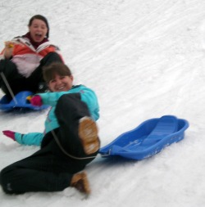
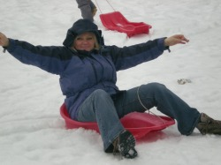
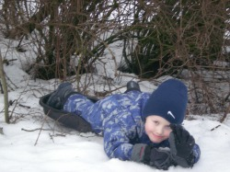
Now that we have all recovered from Christmas, its time to get into a new fun packed year, already we are palnning a head for exciting activities to keep all the children entertained over the coming months. Our February holiday club will be upon us before we know it so please keep an eye out for the holiday club forms which will be out around the 18th of January.

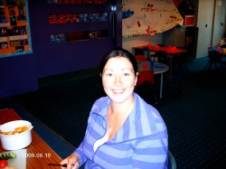
We would all like to say a big congratulations to Lorraine and Ian who had a beautiful baby girl on the 30th of December 2009, they have named her Joni Jean Hamilton and mum and baby are doing just fine, and have been into visit the club to introduce their new addition to everyone, all we can say is she is adorable and we wish them all well.
As Lorraine is on Maternity leave, our new staff member Jillian has joined us, Jillian is a fully qualified nursery nurse and has 19 years experience in working in child care, i have been trying to introduce her to everyone, but if i have not managed to get round to everyone, please feel free to have a chat with her and introduce yourself. Jillian has fitted in really well into our team, and the children all seem to like her a lot too.
We look forward to another fun packed year, and hope its even better than last year, i look forward to seeing you all and hearing your comments and feedback on the club, i operate an open door policy so please feel free to come and chat any time. Also please use this website if you also would like to communicate in any way.

Little Villagers - Livingston Village Out Of School Care Project

