Monthly Newsletter
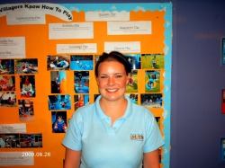
Welcome back everyone, we really hope you enjoyed your summer and are all ready for a fun packed term in the Little Villagers. We would like to welcome all the new children who have registered with us this year, and really hope you all enjoy your time within the little villagers.
I would also like to introduce you all to our new staff member Fiona Docherty who joined our team on the 26th of August, Fiona has been welcomed by us all and the children seem to love her already, Fiona is hoping to become a Primary School teacher in the future, and this will be great experience for her getting started with her career.

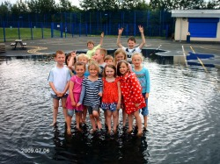
The Summer hoildays this year was a great success and great fun although we didnt have as much sun shine as we hoped for, but this didn't stop us. We had so many activities on the go this year that i dont think the children were ever bored, and the feedback from the children shows they had a fantastic time.
Activities included Arts and Crafts, Baking, Outdoor crafts,Wigwham building, BBQ's, Treasure hunts, Risk and Challenge acticities, Deep Play, River walking, Dance, Puppet making, Kite making, Sports, Ten Pin Bowling, Water games, Trips and outings including the cinema and Blair Drummond Saffari park, this is to name but a few.
This kept everyone so busy and active taht the summer holidays flew in.

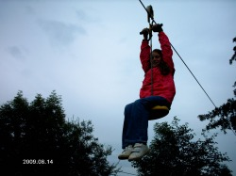
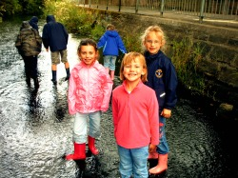
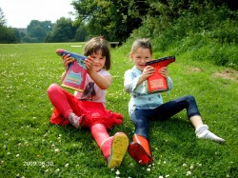
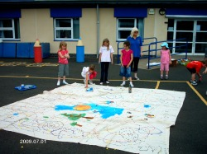
As you can see by some of the photographs the children all had such a good time, and so did the staff. Heres to another new term and so much fun has still to be had, watch this space.

