Spring Newsletter 2017
We hope you all had a great February break!
We have had a busy few months in Little Villagers and the children have been having a fabulous time.

We really enjoyed our panto trip in December where we went to the Kings Theatre in Edinburgh to see Jack and the Beanstalk, it never fails to have all the children and the staff to leave with sore sides from laughing so much. But we have to say the stars of the show was our very own Ben Mackie and Grace Sutherland who were invited up on the stage with the stars of the show, and what a funny performance they gave us.

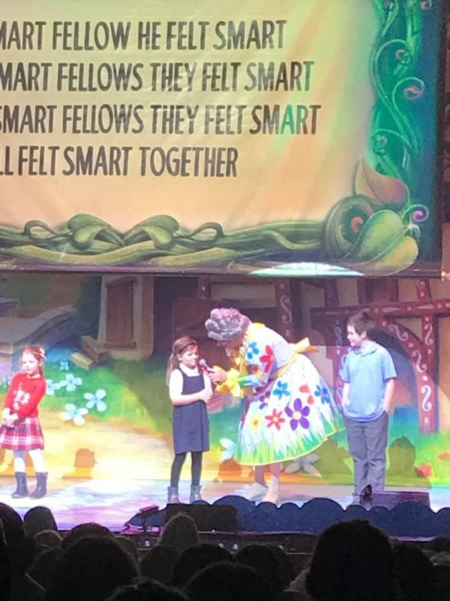

We have to say a huge Thankyou to the Counsellors of West Lothian who kindly gave us donations for our bus hire.

We also had a fantastic lead up to the Christmas holidays where Jillian made the children's dreams come true by making it snow in the club!!!

The children couldn't believe their eyes to what was waiting for them in community room 2, A ROOM FULL OF SNOW!. They had a ball and even some of our parents came into play.

Baby News!
Lesley McGregor, who is currently on maternity leave, gave birth to her Son who she named Lyle, huge congratulations to Lesley and her family.

New Recruit.

We have also welcomed Nicole to our team to cover Lesley. Nicole joined us in January and has previous experience working with children, and has spent time working with the Lothian Autistic Society. Nicole has settled in well and is getting to know all the children.

February Break

In the February Holiday Club the children participated in Valentines crafts and baking activities which they really enjoyed. I'm sure all the parents loved the crafts and the baking the children took home.
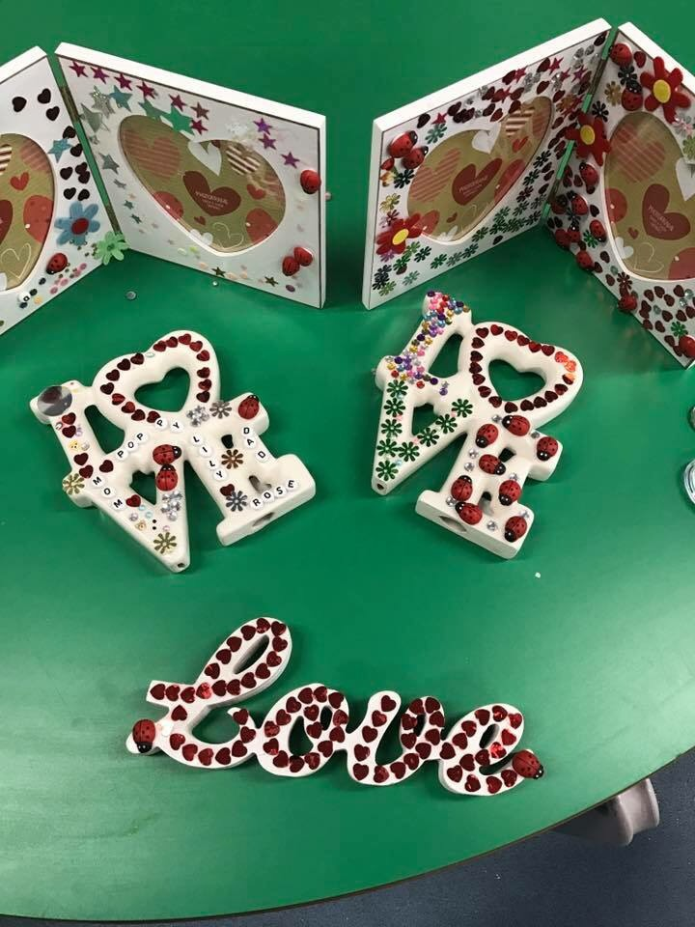

We have welcomed some new children to the club over the past few months, the children are all settled in well and getting to know the club and the staff, and all seem to be loving their time in the club.
Easter Holiday Club is now open:
Please visit our website www.littlevillagers.org.uk to make a booking. You will find the details under the tab "up and coming Holiday clubs" this week we will be consulting with the children on what activities they would like to do over the Easter break.
The activity planner will be up soon for you to see what exciting activities we have on offer.
You can also find all this information on our Facebook page, you will find us by simply typing Little Villagers, pop by and give us a like and keep up to date with all the information on there.
Bookings can be done on all days from Monday 3rd April to Thursday 13th April.
We do not open on Good Friday 14th April and Easter Monday 17th April.
Rates are as follows:
Half Day Session 8am-1pm: £10.50
Full Day Session 1pm to 5.45pm: £19.50
Children who do not attend Livingston Village Primary School are welcome to also attend – please tell your friends and family that our holiday clubs are open to all from ages of 5-16 years!
Yearly registration fee of £10 will apply to new registers.

Dates to remember:
Next Committee Meeting: Wednesday 15th March 2017
7pm-9pm in the parent room within reception. All welcome, please think about joining the committee to have a say in your child’s play!
We meet every 6-8 weeks to discuss the running of the club and how to improve it for all the children.
EGM – Thursday 30th March 2017 7pm-7.15pm
To vote on Treasurer role and amendment to Constitution.
(only Committee Members can vote on this – another good reason to join us!)
We’re Recruiting!!
Role of Treasurer is required – if you have a couple of hours to spare each month collating invoices, dealing with Bank Accounts and staff wages, if you are interested please speak to a member of staff or e mail chairperson@littlevillagers.org.uk
Registration forms.
In May the application/registration forms will be sent out for our existing users to book their places for the new term in August.

These will be sent out by email, so if you can complete them and hand these back into the club when you know what you require for the new term.

We will also have paper copies in the club for anyone new who wishes to join our fantastic club.

New Chair Person

The staff would like to welcome Jodi Conner as our new Chair Person, we are thrilled Jodi has taken on this role and look forward to working closely with her to drive the club forward positively in the future.

We would also like to thank Drew McLellen who has now stepped down as chair, but spent years on our committee.

Nikki and the Team

Note from Chair Person
Hello, I have been on the LV committee since Aug 2016, I have previously been Chair of Parent Council. I am looking forward to the new challenges ahead and working closely with Nikki and the team to make LV even better.

