Clker-free-vector-image, 2018

Acknowledgements.

I would like to take this time to thank the Lectures at Edinburgh College for their educational input, which has helped me develop my knowledge and understanding on Childhood Practice. I would also like to thank the students of the Class of 2018-2019 for their input into each class, which has also given me a better insight into different types of Organisations.
And lastly I would like to thank the Staff and the Management Committee from Little Villagers for supporting me through my learning journey, and giving me the hope and encouragement I needed to get me to this point.

Contents Page.

Overview of Organisation Pages 1 -2
Strategic Areas Page 3
Strategic area 1 – Staff Retention and Development Page 4 -9
Strategic Area 2 – Outdoor Play Provision Pages 10 – 15
Strategic area 3 – Partnership Working Pages 16– 21
Conclusion Page 22
Reference List Pages 23- 25
Bibliography Pages 26- 37

Overview of Organisation.

Little Villagers is an Out of School Club, which provides a Breakfast Club, After School Club and Holiday Club for all children aged between 4 to 16 years within the local community. We are based in the Community Rooms of (School Name).
Little Villagers was introduced to the local community back in August 2004, when the parents of Livingston Village had no child care facilities after their children left Primary 3. This was due to the wraparound facility based within the school only catering for children up to Primary 3.
A group of parents put together a Management Committee to form the basis of what we are now, an Out of School Club. I was employed as Manager before the club opened to the public, and had involvement in putting together the clubs’ policies and procedures, and also liaising with the Care Inspectorate.
The club has grown from strength to strength over the years from starting off in 2004 with 7 Children in our registers, to now having over 70 children registered to date. We are registered for a maximum of 50 Children on a daily basis, and most days we are nearly at our capacity.
We just love the fact that the club has been so successful over the past 18 years and hope that its continued success see us through the next 18 years.

Vision and Aims of Organisation.
“The provision of high quality, affordable, out of school childcare service with fully qualified Play Workers. The children will always be at the centre and really get to play”.

Aims

- Safe and stimulating environment, where children can really experience play opportunities.

- Child centred play experiences, where the children can freely choose what they wish to do.

- Observed by fully qualified Play Workers, who are there to support and broaden the children’s play experiences.

- All staff have knowledge of the Playwork Principle and use this framework to support the childrens’ needs and individual play experiences.

- Where the children’s health and well-being will be met throughout their time in the club. Staff will ensure your child/children are safe; healthy; achieving; nurtured; active; respected; responsible and included.

The Scottish Social Services Council (2015, p6) Standards for Childhood Practice where it states “3.4 provide a service that reflects clear and shared values and respect for individuals”. I feel our Vision and Aims supports this statement.

Strategic Areas for Development

Area 3 Partnership Working
Area 2
Outdoor Play Provision

Area 1
Staff Retention and Development

Staff Retention and Development.

Justification.

This area has been chosen from a consultation process which we carried out with the staff and our users. This process is fundamental in ensuring that all involved have their voices heard and can influence the changes needed to develop the club. This is supported by Cook, J. (2013, p62) who makes reference to the key points when making changes in your establishment. This will ensure that the staff feel supported, and feel positive about what they are doing and how this will make the future of the club better. Having a more qualified Staff group in the specialism of playwork will provide an all-round better play experience for the children in our care.
Key findings from this consultation are outlined in Table 1 below. Identified are the points where we can make positive changes to move the club forward to ensure we are meeting the vision and aims of Little Villagers.
Having a fully trained team with sound knowledge and understanding in the playwork field will only provide an overall better quality of play experience for the children in our care. This is supported by Rodd, J. (2010, p249) suggesting that having quality staff with the right qualifications, and given opportunities for development and training, will ensure they have the most up to date knowledge and understanding. This will result in being more responsive to every child and their families.

Scottish Social Services Council (2008) Continuous Learning Framework is something we will use as a development tool. This will enable the staff to feel supported and continue to develop their own skills, knowledge and understanding.
The SSSC Code of Practice (2016) 3.2 “Contribute to providing social care and social work education and learning, including effective workplace assessments and practice learning”.
Having this in place will ensure we have the most knowledgeable staff, and that the children in our care will have the best support and opportunities we can offer them.
Table 1.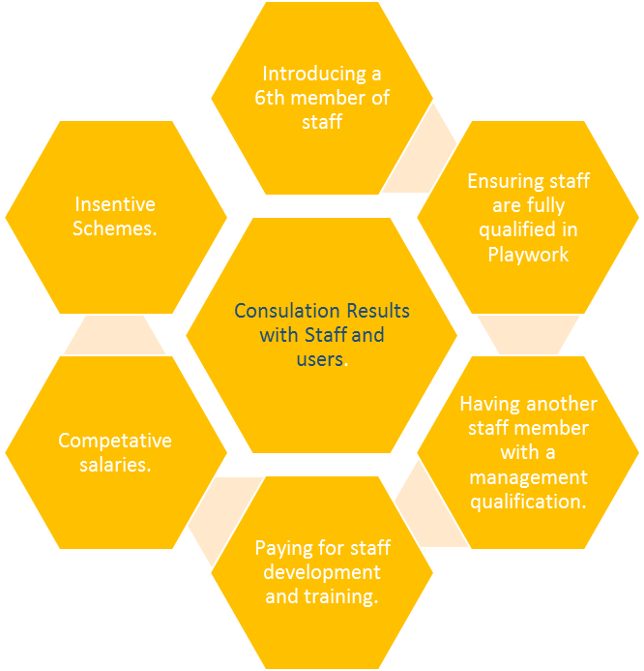

THOM, N. (2019)

Goal 1.
Action Plan | Aim to achieve | Timescale | How will we achieve this? | Resources Needed | How will this be Monitored? | Indication of Success
Having a fully qualified staff in playwork. | All staff will hold a playwork qualification. | August 2022 | Ensuring that staff are identified for this qualification. Through support and supervision, and identified on their CPD. | Information on courses available.  Time to attend.  Having the learning materials.  Mentor each staff member. | Monthly one to ones with Manager.  Support and supervision.  Yearly appraisal process.  Through feedback from mentors.  Observations. | Certificate of qualification.  Change in working practice.  Childhood Practice Standards (SSSC, 2015) 2.4 commitment to reflection and continuous professional development.
 | Identifying best method of education, whether through day release or open learning. | JUNE 2022 | Consultation with staff, one to ones and support and supervision. | Time for one to ones, support and supervision and CPD. | Monthly one to ones to share information.  Weekly team meetings to discuss the positive changes to working practice. | Mentor feedback.  Identifying additional support methods. Childhood Practice Standards (SSSC, 2015) 18.2 support reflection in practice, improve own and colleagues practice.
Introducing SSSC (2008) Continuous Learning Framework. | Using this framework as a development tool. | 2022-2023 | Staff to be aware of this framework and use it to develop their own practice. | Time  Support  Information. | Monthly team meetings  One to ones  Support and Supervision  Appraisal system and CPD. | Having this as part of their development and working alongside this framework It states “recognises that everyone in the organisation is a lifelong learner” SSSC (2008, p38) Continuous Learning Framework .

Goal 2.
Action Plan | Aim to achieve | Timescale | How will we achieve this? | Resources Needed | How will this be Monitored? | Indication of Success.
Introducing a 6th staff member. | Having the budget to put this in place. | August 2022 | By increasing the fees, whilst ensuring we are still affordable. | Forecast of the expense on how much this will impact on the clubs funds.  Having funding behind us to start the process. | Consultations with the Management Committee. Looking at the forecast to ensure we are within our budget. | The increase of fees to have the finances in place to start the recruitment process. Childhood Practice standards (SSSC, 2015) 25.4 plan and control budgets.
 | Employing a 6th member of staff. | June 2022 | Start the recruitment process by using the framework Safer recruitment, through better recruitment (2007) Follow the SSSC guidelines SSSC CODES OF PRACTICE (2016) – 1.1 use thorough recruitment processes to make sure that only suitable people with appropriate attitudes and values, and the potential to gain the necessary knowledge and skills, enter the workforce. | Time to run the job advertisement. | 6 weeks - review and shortlist the candidates.  Interview process.  PVG application  Induction process,  PVG.  One to ones, support and supervision.  Treasurer reports on finances. | Introducing a 6th staff member to the children, parents and team.  Staff less stressed from working under ratios to cover holidays or sickness.  Continuity for the children.  Childhood Practice standards (SSSC, 2015) 25.3 develop procedures for the safe selection, recruitment.
 | Maintaining a 6th staff member. | 2022 - 2023 | Annual fee increase to ensure the funding is there to keep a 6th staff member. | Financial reports from Treasurer. | Feedback from Manager on how this has impacted the club. | A consistent staff team.

Goal 3.
Action Plan | Aim to achieve | Timescale | How will we achieve this? | Resources Needed | How will this be Monitored? | Indication of Success.
Incentives for staff. | Ensuring that we keep the good staff we have. | 2022 -2023 | Having bonus schemes/ staff incentives schemes or scale for good performances. | Funding – This would come through the fee increase. | Staff rewarded for achievements. Recognition for their hard work and dedication, which will be documented through support; supervision, and appraisals. | Keeping the good team we have in place for long term, and reducing high turnover in staff.  Childhood Practice standards (SSSC, 2015) 25.3 retention of workers.

(Clker-free-vector-image, 2018)

Outdoor Play Provision.

Justification.
The users from Little Villagers were issued with questionnaire and asked what improvements they would like to see when it came to the play provision we provide. The results are shown in Table 2 below.
As play is a vital part of the children’s health and well-being, it is important we get it right. Allowing children to have the right play experiences will help with:-
- Their physical well-being
- Social and communication skills
- Emotional and creative needs
Children learn through play, and the skills they develop are skills which will serve them well in later life. Learning through play (The Lego Foundation, 2018, p8) supports this by stating “Play sets the foundations for development of critical social and emotional knowledge and skills”.
This is supported by Getting it Right for Play (Play Scotland, 2011) who promote the importance of play, and look to create more play opportunities for children and young people in the community. They have devised performance indicators through their tool kits. I will introduce these to the staff, and put them into our working practice. Introducing and using these tool kits will give the practitioners an opportunity to reflect and evaluate the opportunities we offer and where we feel there is scope for development.
We will also be using How good is our early learning and childcare (Education Scotland, 2016 p4) performance indicators which provides national guidance where practitioners and others can work together to reflect and evaluate their impact on improving outcomes for children in their local community.
We intend to use other frameworks to ensure that we carry out this area to the best of our abilities. These support the need for more outdoor play provisions by:-
- Scottish Government, Play Strategy for Scotland: Our Vision (2013, p19) states that outdoor play provides a powerful and enriched play experiences, which should be given on a daily basis. Which our feedback has identified.
- Care Inspectorate, My World Outdoors (2016, p11) also outlines and explains the benefits of outdoor play. These include identifying the rights for children to play outdoors. Children should be able to explore their natural environments, with appropriate resources to support their learning and development, which also promotes a healthier lifestyle. Allowing children the opportunity to manage risk will give them confidence and a sense of achievement.
- United Nations Convention on the Rights of the Child (UNCRC) (1991) article 31 also promotes the rights for children to experience leisure, play and Culture.
The Health and Social Care Standards, My Life, My Support (2018) Standard 2 - refers to the children being in control of what they would like to do. Little Villagers has listened to the childrens’ requests for more outdoor play.
This is also supported in standard 5.1 which state “I can use an appropriate mix of private and communal areas, including accessible outdoor space, because the premises have been designed or adapted for high quality care and support.”

TABLE 2. Thom, N (2019)

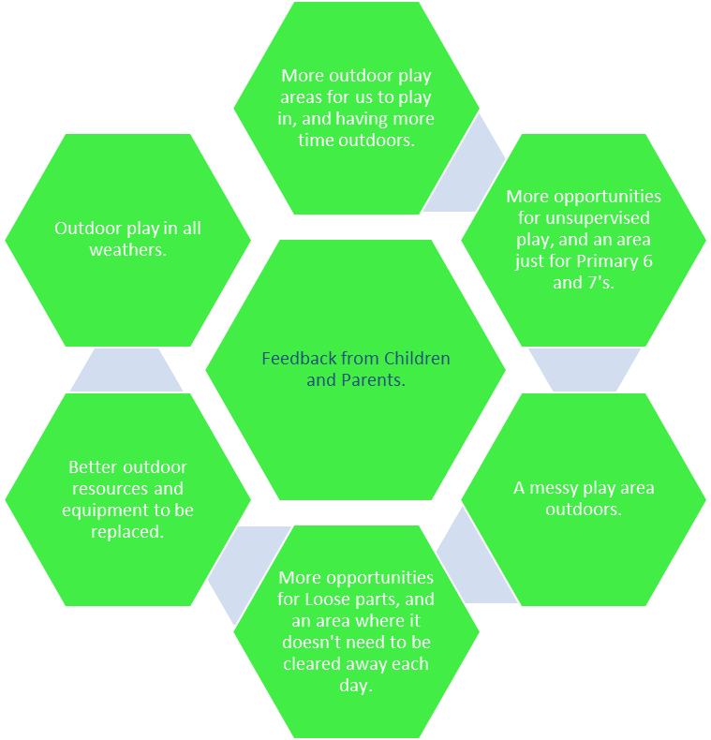

Goal 1.
Action Plan | Aim to achieve | Timescale | How will we achieve this? | Resources Needed | How will this be Monitored? | Indication of Success.
Outdoor play spaces | Children will have outdoor play spaces to explore their natural environment. | 2022-2023 | By developing an additional play area, where children can freely do as they choose. | Time.  Consultations with Council and School. | Through meetings with relevant sources.  Staff meetings. | By having a fully operational play space for children to be creative. Care Inspectorate, My World Outdoors (2016, p11)  “Routine access to a stimulating outdoor play area including daily opportunities to spend time outdoors”.

Goal 2.
Action Plan | Aim to achieve | Timescale | How will we achieve this? | Resources Needed | How will this be Monitored? | Indication of Success.
Staff to have sound knowledge of play and the benefits on this. | Staff to have up to date knowledge and understanding on the play and the play process. And introducing Getting it Right for Play performance indicators. | 2022 – 2023 | By staff completing Playwork qualifications.  By staff using the indicators identified in their working practice. | Information on courses available.  Time to attend classes.  Having the learning materials they need in place.  Providing training for staff to use the indicators. | Monthly one to ones with Manager. Support and supervision. Appraisal process.  Feedback from mentors.  Observations in working practice. | Certificate of qualification. Childhood Practice Standards (SSSC, 2015)  16.1 plan, implement and justify balanced and flexible programmes

Goal 3.
Action Plan | Aim to achieve | Timescale | How will we achieve this? | Resources Needed | How will this be Monitored? | Indication of Success.
Providing better opportunities for loose parts play. Nicolson. S (1971). | Having an identified area. | 2022 - 2023 | By having an area where loose parts can remain and children can pick up where they left off. | An area to do this.  Consultation with Council and School. | Through meetings with relevant sources.  Staff meetings. | An area located for this to happen. This is supported by Casey, T (2007, p 35) suggests loose parts extends endless possibilities for play.

(Clker-free-vector-image, 2017)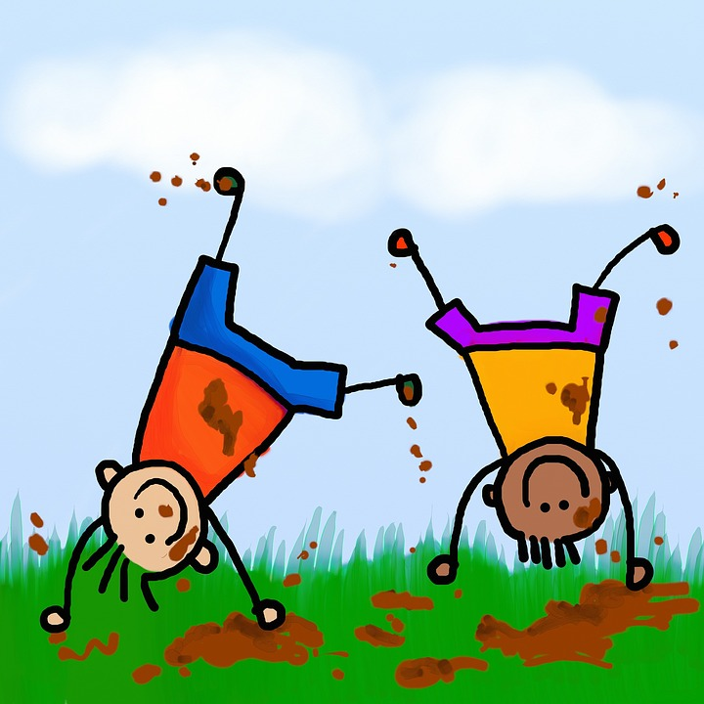

Partnership Working.

Justification.
Identifying and working in partnership within our local community is something we feel could be developed more. Having this integrated into the service will benefit the children and families for which we provide care.
Identifying agencies in the community we can work with to support families who need additional support will result in the correct support being given. It allows us as practitioners the ability to support the child more within our setting, leading to better outcomes and a better future for the child and their families. A common aim to work towards (see Table 3 below).
Macleod-Brudenall, I. Kay, J (2008, p265) states “Partnership is a gateway to providing additional support where parents are struggling to meet the needs of their children”. And as an organisation with children at the centre, it is important for us to ensure this is happening within our working practice.
Getting it Right for Every Child (GIRFEC) was introduced by the Scottish Government in 2008. This was introduced to improve working practice for professionals working with children and families. The well –being indicators are assessment tools within GIRFEC, which are there to allow professionals to assess and reflect on all the areas within a child’s life.

This is the framework and evaluation tool we would use to ensure that all children in our care are thriving within these areas. If not, we would then aim to put the support in place by liaising with the correct professionals to ensure the well-being of the children are being fully met.
The Children and Young Peoples (Scotland) Act 2014 makes important changes to the development of services for children and their families. Within this Act one aim is to support and promote the well-being of all children and identifies the importance of having childrens’ plans in place. This will help practitioners identify and implement additional support where children may need intervention.

TABLE 3.
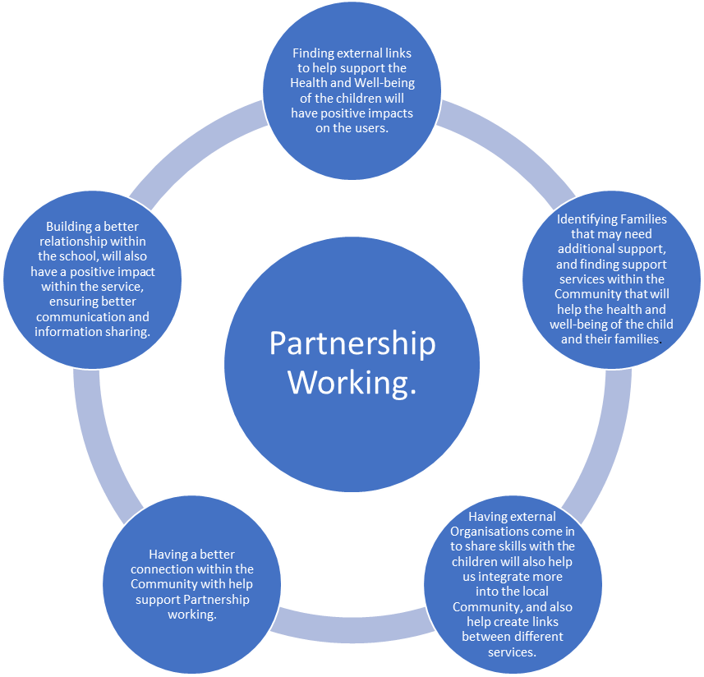Thom, N. (2019)

Goal 1.
Action Plan | Aim to achieve | Timescale | How will we achieve this? | Resources Needed | How will this be Monitored? | Indication of Success.
Close partnership working in the community. | Identify/Develop stronger relationships within the community to help support our users. | 2021-2022 | By identifying other sources available to us within the community which will benefit our service users. Making new connections. | Time  Information  Time to create new links | Monthly team meetings.  Attending cluster meetings.  Feedback to management committee.  Consistent contact | Identifying and using new formed partnerships within Little Villagers to support the needs of the children.  Childhood Practice Standards (SSSC, 2015)  21.2 proactive in developing working relationships inter professional. Networks and organisations in order to strengthen support for children and young people and families.

Goal 2.
Action Plan | Aim to achieve | Timescale | How will we achieve this? | Resources Needed | How will this be Monitored? | Indication of Success.
Engaging in the community. | Forming relationships within the community where we can enhance and promote each other’s service. | 2021- 2022 | Finding new ways to engage with people that we have not successfully involved before.  Create a contact point for local communities to directly communicate with the Partnership and services. | Time.  Information.  Time to attend meetings to create these links. | Feedback from all involved during scheduled meetings.  Feedback from our services users to reflect on the changes. | Having a stronger connection within the community. Sharing information on other services which will benefit our users. Childhood Practice Standards (SSSC, 2015) 3.7 promote developing communities, community involvement and active citizenship.

Goal 3.
Action Plan | Aim to achieve | Timescale | How will we achieve this? | Resources Needed | How will this be Monitored? | Indication of Achievement.
Ensure professional support and help is available for families where there are wellbeing concerns or additional support needs identified. | Identifying additional support for families and provide them with the correct information on services which will support them. | 2021-2023 | Creating links with the external agencies.  Using the well-being indicators to help reflect on how we can support the child or families. | Staff Training.  Time.  Creating external links.  Time to attend meetings. | Parent and children consultations.  Monthly Team meetings.  External agency meetings. | A change in working practice with evidence. How good is our early learning and childcare (Education Scotland,2016, p6) Children’s learning in health and wellbeing is enhanced through effective partnership working with parents/carers and partners
(Clker-free-vector-image, 2014)
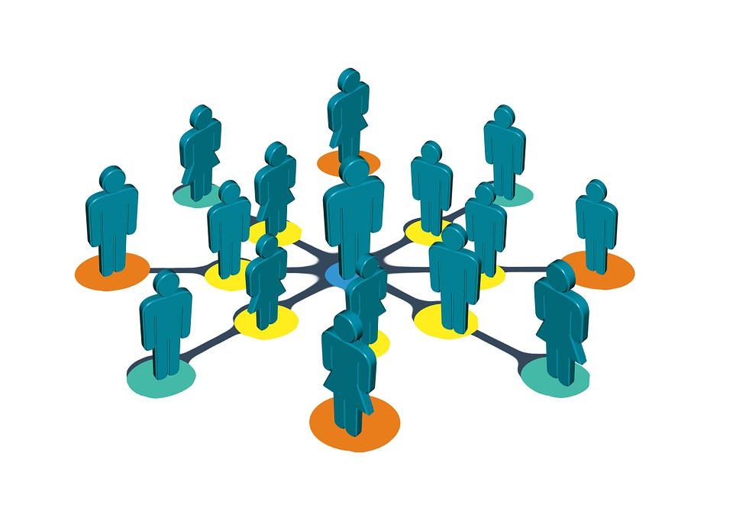

Conclusion.

These 3 strategic areas will definitely have a positive impact on Little Villagers and the children, whilst improving all round better outcomes for the health and well-being of all the children in our care.
Having the most knowledgeable staff in their field of playwork will only enhance the play experiences we offer the children. We must ensure that their voices are always heard and staff are then able to facilitate their needs to their highest standards. The staff will be able to benchmark themselves against the Childhood Practice Standards (SSSC) (2015, P7) “Managers/lead practitioners value themselves and others by taking responsibility for their own professional learning and development and that of the workers for whom they are responsible”.
Offering better outdoor provision for the children in our care enhances better play/learning experiences, as supported by the Playwork Principles “All children and young people need to play. The impulse to play is innate. Play is a biological, psychological and social necessity, and is fundamental to the healthy development and well-being of individuals and communities. This is supported by United Nations Convention on the Rights of the Child (UNCRC) (1991) article 31 also promotes the rights for children to experience leisure, play and Culture. Ensuring we have the best possible outdoor play provision will strengthen what we have to offer and positively impact the children in our care. Space to Grow (2017, p12) also positively promotes the opportunities for children to play outdoors and the positive impacts which the environment can provide.

Providing more resources when it comes to working in partnership with other agencies will support the children and families within our services; offering more support where and when it’s needed. These connections made within our community will only improve personal outcomes for our users, which will have a positive impact on the children we care for. This is supported in the Childhood Practice Standards (SSSC) (2015, P7) “Managers/lead practitioners value, respect and show commitment to the parents and carers, families, communities and other agencies and partnerships with whom they work”.
Our goal is always to have the children at the centre, and provide the best play experiences we possibly can.

Reference List.

Care Inspectorate. My World Outdoors, 2016) Available at: http://www.careinspectorate.com/images/documents/3091/My_world_outdoors_-_early_years_good_practice_2016.pdf
(Viewed 18.5.19)
Casey, Theresa (2007) – Environments for Outdoor Play: A Practical Guide to Making Space for Children London: Paul Chapman Educational Publishing
Clker-Free-Vector-image (2018) Image: boys-girls-kid-children-playing. Available online https://pixabay.com/vectors/boys-girls-kids-children-playing-3350811/
(Viewed 21.5.19)
Clker-Free-Vector-image (2017) Image: kids-children-cute-childhood. Available online https://pixabay.com/illustrations/kids-children-cute-childhood-2030268/
(Viewed 21.5.19)
Clker-Free-Vector-image (2018) Image: Team-Teamwork-together-strategy. Available online https://pixabay.com/photos/team-teamwork-together-strategy-3393037/
(Viewed 21.5.19)
Clker-Free-Vector-image (2014) Image: Social-media-personal. Available online https://pixabay.com/illustrations/social-media-personal-581783/
(Viewed 21.5.19)
Cook, J (2013) Leadership and Management in Early Years. London; Practical Pre-School Books
Department of Children, Schools and Families, 2003. Every Child Matters. Available at: https://assets.publishing.service.gov.uk/government/uploads/system/uploads/attachment_data/file/272064/5860.pdf
(Viewed 16.5.19)

Education Scotland (2016) How good is our early learning and childcare. Available at: https://education.gov.scot/improvement/Documents/Frameworks_SelfEvaluation/FRWK1_NIHeditSelf-evaluationHGIELC/HGIOELC020316Revised.pdf

(Viewed 17.5.19)

MacLeod-Brudenell, I. and Kay, J. (Eds.) (2008) Advanced Early Years: Foundation Degrees & Levels 4/5.Second edition. Heinemann.
Play Scotland (2011) Getting it Right for Play. Available at: https://www.playscotland.org/wp-content/uploads/assets/Toolkit.pdf
(Viewed 16.5.19)
Rodd, J. (2010) Leadership in Early Childhood 4th Edition. Maidenhead; Open University Press
SSSC (2015) Standards for Childhood Practice available at: http://www.stepintoleadership.info/assets/pdf/2015-Standard-for-Childhood-Practice.pdf (viewed 21.5.19)
Scottish Social Services Council, Codes of Practice (2016) Available at: file:///C:/Users/nikki/AppData/Local/Packages/Microsoft.MicrosoftEdge_8wekyb3d8bbwe/TempState/Downloads/Codes%20of%20Practice%20for%20Social%20Service%20Workers%20and%20Employers%20(1).pdf
(Viewed 12.5.19)

Scottish Government. Children and Young Peoples (Scotland) Act 2014 Available at: https://www.gov.scot/publication/children-young-people-scptland-act-2014-national-guidance-part-12/pages/3//
(Viewed 13.6.19)

Scottish Government. Health and Social Standards My Support, My Life (2018) available at: https://hub.careinspectorate.com/media/2544/sg-health-and-social-care-standards.pdf
(Viewed 13.6.19)

Scottish Government. Play Strategy for Scotland; Our Vision (2013) Available at: http://www2.gov.scot/resources/0042/00425722.pdf
(Viewed 18.5.19)

Scottish Government, Space to Grow (2017) Available at: https://blogs.glowscotland.org.uk/ce/EarlyYears/files/2017/07/Space-to-Grow.pdf
(Viewed 14.6.19)

SCRUTINY GROUP CARDIFF. 2005. Playwork Principles. (Online) available at: http://www.skillsactive.com/PDF?sectors/playwork_Principles.pdf
(Viewed 21.5.19)
The Lego Foundation. 2018. Learning through Play. (Online) available at: http://www.unicef.org/sites/default/files/2019=8-12/UNICEF-Lego-foundation-Learning-through-play.pdf
(Viewed 13.6.19)
Thom, N. (2019) Presentation Current Thinking. Edinburgh College

UN Convention on the Rights of the Child (1991) Available at: https://downloads.unicef.org.uk/wp-content/uploads/2010/05/UNCRC_summary-1.pdf?_ga=2.32621691.438508940.1555591358-1220506683.1504877113
(Viewed 18.5.19)

Bibliography
Adair, J. (2010) Effective Strategic Leadership: The Complete Guide to Strategic Management. Revised edition. Pan Books.
Alderson, P (2008) Young Children’s Rights, Jessica Kingsley Publishers: London
Almon, J (2017) Playing it up with Loose Parts, Playpods and Adventure Playgrounds. Annapolis. Alliance for childhood publication

Arnold, A. (2011) Working with parents: Key Issues. London: Featherstone Education.

Aubrey, C. (2009) Leading and Managing in the Early Years Second Edition. London: Sage.

Blatchford, S. (2001). Diversity and Learning in the Early Years. In: Pugh, G. Contemporary Issues in Early Years. 3rd ed. London: Paul Chapman.
Beckley, P. Elvidge, K. Hendry, H. (2009) Implementing the Early Years Foundation Stage: A Handbook. Maidenhead; Open University press.
Bolton, G (2006) Reflective Practice 2nd Edition London: Sage Publishing
Brett Davies, M (2007) Doing a successful research project: using qualitative or quantitative methods, Basingstoke: Palgrave Macmillan
Brock et al (2009) Perspectives on Play; Learning for Life Harlow: Pearson Education Ltd
Brooks, Libby, (2006). The Story of Childhood. Growing up in Modern Britain. London; Bloomsbury.

Brown F (2003) Playwork: theory and practice London: Open University Press
Brown, F. 2009. What is playwork. (Online) Available at: http://playwprkfoundationorg.files.wordepress.com/2016/03/no-14_what_is_playwork.pdf
Brown F and Taylor C(Ed) (2008) Foundations of Playwork Maidenhead: Open University Press
Brown S (2010) Play. How it shapes the brain, opens the imagination and invigorates the soul New York: Penguin
Bruce T (2001) Learning through Play - Babies, Toddlers and the Foundation Years London: Hodder Education
Bryson, J. Alston, F. (2011) Creating your Strategic Plan. A workbook for public and non Profit organisations. San Francisco; Wiley & Sons.

Campbell-Barr, V. Leeson, C. (2016) Quality Leadership in the Early Years. London: Sage Publications
Care Inspectorate, Children and Young peoples (Scotland) Act 2014 (online) available at http://hub.careinspectorate.com/knowledge/policy-and-legislation/policy-portals/children-young-people-(scotland)-act/
Care Inspectorate, 2013. Better results in partnership (online) available at http://carenews.careinspectorate.com/better-results-in-partnership/
Care Inspectorate. My World Outdoors (2016) Available at: http://www.careinspectorate.com/images/documents/3091/My_world_outdoors_-_early_years_good_practice_2016.pdf

Casey, Theresa (2005) Inclusive Play – Practical Strategies for working with children aged 3-8 London: Paul Chapman Educational Publishing
Casey, Theresa (2007) – Environments for Outdoor Play: A Practical Guide to Making Space for Children London: Paul Chapman Educational Publishing
Children’s Act 1989. Available at: http://www.legislation.gov.uk/ukpga/1989/41/section/47
Children (Scotland) Act (1995) Available at: https://www.gov.scot/publications/scotlands-children-children-scotland-act-1995-regulations-guidance-volume-1-support-protection-children-families/pages/2
Children’s Play Council (2004) Planning for Play London: Children’s Play Council. Available online at http://www.playengland.org.uk/media/120480/planning_for_play.pdf

City of Edinburgh Council (no date) Getting It Right for Every Child in Edinburgh, Available [online] http://www.edinburgh.gov.uk/girfec

Clark and Moss (2011) Listening to Young Children: The Mosaic Approach National Children's Bureau: London
Cojocaru, M (2016) Brain Development and Early Learning (online) Available at: http://playtothinksmart.hk/brain-development/brain-development-and-early-learning/
Cole, G.A. (2003) Management Theory and Practice. Sixth edition. London: Thomson Learning.

Cole, G.A. and Kelly, P. (2011) Management Theory and Practice. Seventh edition. Andover: Centage Learning
Cole-Hamilton I (2011) Getting it Right for Play The Power of Play: an evidence base Play Scotland available online at http://www.playscotland.org/getting-it-right-for-play/
Cook, J (2013) Leadership and Management in Early Years. London; Practical Pre-School Books
Cottrell S, (2011) Palgrave Study Skills, Critical Thinking Skills. Basingstoke;Palgrave Macmillan.
Cottrell, S (2011) Critical thinking skills, 2nd edition, Basingstoke: Palgrave Macmillan
Daly, M., Byers, E. and Taylor, W. (2009) Early Years Management in Practice. Second edition. Essex: Heinemann.
Davis, J (Ed) (2006) Children, Young People and Social Inclusion: Participation for What? Policy Press

Deacon S (2010) Joining the Dots – A Better Start for Scotland’s Children, an independent report: Available [online] http://www.scotland.gov.uk/Resource/Doc/343337/0114216.pdf

Department of Children, Schools and Families, 2003. Every Child Matters. Available at: https://assets.publishing.service.gov.uk/government/uploads/system/uploads/attachment_data/file/272064/5860.pdf

Disability Discrimination Act (2005) Available at: http://assets.publishing.services.gov.uk/government/uploads/systems/uploads/attachments_data/file/228870/9780108508066.pdf

Education Scotland. (2008) Building Links and Partnerships within the Community. Available [online] http://www.educationscotland.gov.uk/supportingstudents/partnershipsforsupport/buildinglinks.asp

Education Scotland (2016) How good is our early learning and childcare. Available at: https://education.gov.scot/improvement/Documents/Frameworks_SelfEvaluation/FRWK1_NIHeditSelf-evaluationHGIELC/HGIOELC020316Revised.pdf

Educating Scotland (2011) Outdoor Learning: Practical Guidance ideas and support for Teachers and Practitioners in Scotland (online) Available at: http://education.gov.scot/improvement/documents/hwb24-ol-support.pdf

Education Scotland (2011) The Curriculum in Scotland Available at: http://www.educationscotland.gov.uk/thecurriculum/

Education Scotland Foghlam Alba. Pedagogical in Early Learning and Childcare (online) Available at: http://education.gov.scot/improvement/documents/elc24-pedagogical-leadership.pptx

Else P (2009) The Value of Play London: Continuum Publishing

Else, P (2014) Making Sense of Play. Maidenhead: Open University Press

Equality Act (2010) http://www.legislation.gov.uk/ukpa/2010/15/section/39

European Government (2018) General Data Protection Regulation (GDPR) Available [online] https://gdpr-info.eu/

Froebel Web (2008) Available at http://www.froebelweb.org/web7001.html
Garvey C (1990) Play Cambridge, Mass.: Harvard University Press

Garvey, D. (2010) Leadership for Quality in Early Years and Playwork. London: National Children’s Bureau.

Gasper, M (2010) Multi-Agency Working in the Early Years: Challenges and Opportunities Sage: London
Gill T (2007) No Fear: Growing up in a Risk-averse Society London: Gulbenkian Foundation
Gray, P. (2014) Risky Play: Why Children Love it and Need it (online) http://www.psychologytoday.com/us/blog/freedom-learn/201404/risky-play-why-children-love-it-and-need-it?amp

Greenland, P. (2010) Physical development, In Bruce, T. (Ed), Early Childhood. A guide for Students. London, sage.

Griffin, S (2008) Inclusion, equality and diversity in working with children, Heineman: Harlow

Guidance on adult to child ratios in Early Learning and Childcare (ELC) settings (2018) available at: http://www.careinspectorate.com/images/ELC_adult-child_ratios_-_final_29.3.18.pdf

Healing. “The Colorado Paper”, Leigh-on-Sea: Ludemos Press.

HMIe (2007) Child at the Centre (2) Available [online] http://www.educationscotland.gov.uk/earlyyearsmatters/t/genericcontent_tcm4453334.asp

HMIE (2012) Promoting race equality: making it happen: schools working to secure success for all and positive attitudes towards diversity Available at: http://dera.ioe.ac.uk/6233/

Hudson, D. (N/D) (online) available at: https://www.dreamstime.com/royalty-free-stock-photos-kids-play-image187238

Hughes, B (1996) A Playworker’s Taxonomy of Play Types, London: PLAYLINK, UK. Available on: http://www.playscotland.org/playful-learning/play-types/

Hughes B (2001) The First Claim. A framework for playwork quality assessment Cardiff: Play Wales

Hughes B (2006) Play Types – Speculations and Possibilities London: London Centre for Playwork Education and Training
Hughes B (2012) Evolutionary Playwork London: Routledge

Hughes B (2012) Evolutionary Playwork and Reflective Analytic Practice 2nd edition. London: Routledge

Lawson, A. and Marotz, L. (2006) Motivational Leadership in Early Childhood Education. Wadsworth: Centage Learning.

Lcoos (Lane cove out of schools) (2018) (online) available at: www.lcoos.com.au/2014/01/risk-taking-childrens-play/

Lester, S. Russell, W. (2008) Play for a change, Full Report London: National Children’s Bureau available on-line at http://www.playengland.org.uk/resources/play-for-a-change---play,-policy-and-practice-a-review-of-contemporary-perspectives

Lester, S. Russell, W. (2010) ‘Children’s right to play’, An examination of the importance of play in the lives of children worldwide Working Paper No. 57. The Hague, The Netherlands: Bernard van Leer Foundation.

Lillemyer 0 (2009) Taking Play Seriously. Children and Play in Early Childhood Education - An Exciting Challenge Information Age Publishing: Trondheim

Lindon J (2001) Understanding Children’s Play Cheltenham: Nelson Thornes Ltd

Johari windows. Model. Luft, J Ingham, H. (1955)
Johnson, J (2015) How to be a great leader in Early Years. London;Jessica Kingsley

Jones, C. Pound, L. (2010) Leadership and Management in the Early Years. Maidenshead; Open University press.

Jones, J (2005) Management Skills in Schools A resource for School Leaders. London; Sage Publishing

Jones, P. (2011) Strategy Mapping for Learning Organizations: Building agility into your Balanced Scorecard.
Jones, P and Walker, G (Eds) (2011) Children’s rights in practice, Sage Publications Ltd: London

Jones, P. Welch, S. (2013) Rethinking Children’s Rights. London: Broomsbury

MacDonald, D (2009) Heads Learning Log. (Online) Available at: http://www.libertonheadsblog.blogspot.com/2009/08/getting-it-right-for-every-child-in.html

MacLeod-Brudenell, I. and Kay, J. (Eds.) (2008) Advanced Early Years: Foundation Degrees & Levels 4/5. Second edition. Heinemann.
Mainston-Cotton. S, 2017. Promoting young children’s emotional health and wellbeing- A practical guide for professionals and parents. London: Jessica Kingsley Publishers
Manning-Morton. J, 2014. Exploring wellbeing in early years. Maidenhead: Open University Press
Martin, B (2011) Children at Play: Learning Gender in the Early Years. Stoke-on-Trent: Institute of Education Press.

McLeod, S. (2016) Simply Psychology. Social Learning Theory available at: https://www.simplypsychology.org/bandura.html
McKeown, M (2012) The Strategy Book. Harlow: Pearson Education Ltd.

Miller, L & Hevey, D. Ed. (2012) Policy Issues in the Early Years. London; Sage Publications Ltd
Miller, R (2012) Clearly Outstanding. Great Britain; bookshaker publications.

Moon, J (2005) Learning Journals 2nd Edition. Abingdon: Routledge.

Musgrave. J, 2017. Supporting Children’s health and wellbeing. London: Sage Publications limited

National Playing Fields Association, Children’s Play Council and PLAYLINK (2000) Best Play: What Play Provision Should Do for Children London: NPFA. Available online at http://www.playengland.org.uk/resources/best-play.aspx

National Records of Scotland (2011) Scotland’s Census Shaping our future (online) available at https://www.scotlandscensus.gov.uk/ods-web/area.html

Newstead, S. and Isles-Buck, E. (2012) Essential Skills for Managers of Child-Centred Settings. Second edition. Abington: Routledge.

Nutbrown C (Ed.) (1996) Respectful Educators - Capable Learners London: Paul Chapman

Nutbrown K (2005) Key Concepts in Early Childhood Education and Care London: Sage Publications Ltd
Olsen, E G. (2011) Strategic Planning for dummies 2nd edition. Indianapolis; Wiley & Sons
On Strategy, (2010) What is the difference between a business plan and a strategic plan. Available [online] at http://onstrategyhq.com/resources/what-is-the-difference-between-a-business-plan-and-a-strategic-plan/

Outdoor Learning, a Practical guidance, ideas and supports teachers and Practitioners in Scotland (2011) Education Scotland. Available at: https://education.gov.scot/improvement/Documents/hwb24-ol-support.pdf

Participation Works Partnership (PWP) (no date) Let's Listen Young Children's Voices Profiling and Planning To Enable Their Participation In Children's Services. Available [online] http://www.participationworks.org.uk/resources/lets-listen-young-childrens-voices-profiling-and-planning-to-enable-their-participation-in

Pearce-Stevens, A. (2014) Learning rewires the brain. (Online) Available at: https://www.sciencenewsforstudents.org/article/learning-rewires-brain
Play Scotland (2011) Getting it Right for Play. Available at: https://www.playscotland.org/wp-content/uploads/assets/Toolkit.pdf
Playlink (2001) Making sense: Playwork in Practice London: Playlink. Available online at http://www.freeplaynetwork.org.uk/practice/

Playwork Principles Scrutiny Group (2005) Playwork Principles Held in trust by Play Wales. Available online at http://www.playscotland.org/what-is-play-playwork/information-on-playwork

PILHOFER, K (2011) Cultural Knowledge - A Critical Perspective on the Concept As a Foundation for Respect for Cultural Differences. Hamburg: Diplomica Verlag.
Prout A (2010) the Future of Childhood. Abington; Routledge

PVG Scotland Act, 2007 (online) available online at: http://www.gov.scot/Publications/2008/09/29114859/2

Ridley, D (2012) The Literature Review – a step by step guide for students, 2nd edition, London: SAGE publications
Robins, A. and Callan, S. (Eds.) (2008) Managing Early Years Settings: Supporting and Leading Teams. London: Sage.
Rodd, J. (2006) Leadership in Early Childhood: The Pathway to Professionalism. Third edition. Maidenhead: Open University Press.
Rodd, J. (2010) Leadership in Early Childhood 3rd Edition. Maidenhead; Open University Press
Rodd, J. (2013) Leadership in Early Childhood. Open University Press.

Scotland, A Guidance to Playwork. Available at: https://www.playscotland.org/playful-learning/information-on-playwork
Scottish Charity Regulator (2018) OSCR; Safeguarding. Online available from https://www.oscr.org.uk/news/safeguarding-and-notifiable-events-two-key-points-for-your-next-meeting
Scottish Executive, 2006. Getting it Right for every child, Implementation Plan (online) available at file:///C:/Users/HP%20Envy/AppData/Local/Microsoft/Windows/INetCache/IE/DJT4PRRI/0031397.pdf
Scottish Executive, 2006 Getting it Right for Every Child. GIRFEC Principles and Values. Available at: https://www.gov.scot/policies/girfec/
Scottish Government. (2008) Achieving Our Potential. Available [online] http://www.scotland.gov.uk/Publications/2008/11/20103815/0
Scottish Government (2015) Building the Ambition: National Practice Guidance on Early learning and Childcare Children and Young People (Scotland) Act 2014. Available [online] http://www.gov.scot/Resource/0045/00458455.pdf
Scottish Government. (2012) Children’s Legislation. Available [online] http://www.scotland.gov.uk/Topics/People/Young-People/legislation
Scottish Government. (2009) Early Years Framework (EYS) Available [online] http://www.scotland.gov.uk/Publications/2009/01/13095148/0
Scottish Government (2010) Early Years Framework: Progress So Far Available. [Online] http://www.scotland.gov.uk/Publications/2011/01/13114328/0
Scottish Government (2008) Equally Well. Available [online] http://www.gov.scot/Resource/Doc/229649/0062206.pdf
Scottish Government (2001) For Scotland’s Children Report. Better integrated children’s services. Available [online] http://scotland.gov.uk/Publications/2001/10/fscr
Scottish Government (2006) Getting It Right for Every Child (GIRFEC) Available [online] http://www.scotland.gov.uk/Topics/People/Young-People/gettingitright
Scottish Government (2012) Getting It Right For Every Child Available at: http://www.scotland.gov.uk/Topics/People/Young-People/gettingitright
Scottish Government, 2016. Getting it right for every child, Child’s plans (online) available at file:///C:/Users/HP%20Envy/AppData/Local/Microsoft/Windows/INetCache/IE/1T8M8L7Y/00500764.pdf
Scottish Government, 2016. Getting it right for every child. Understanding wellbeing (online) available at
file:///C:/Users/HP%20Envy/AppData/Local/Microsoft/Windows/INetCache/IE/ZBU3O4DN/00500774.pdf
Scottish Government (2011), Growing Up In Scotland Centre for Research on Families & Relationships: Available [online] http://www.growingupinscotland.org.uk/
Scottish Government, 2016. Named Person (online) available at http://www.gov.scot/Resource/0050/00500763.pdf
Scottish Government, 2017. Well-being (online) available at http://www.gov.scot/Topics/People/Young-People/gettingitright/wellbeing

Scottish Government (2009) National Care Standards: Early Education and Childcare up to the Age of 16 Available at: http://hub.careinspectorate.com/knowledge/national-care-standards/services-for-children-and-young-people/
Scottish Government (2013) Play Strategy for Scotland, Our Vision Available at: http://www.gov.scot/Resource/0042/00425722.pdf
Scottish Government (2004) Protecting Children and Young People – The Charter. Available [online]: http://www.scotland.gov.uk/Publications/2008/11/20103815/0
Scottish Government (2013) the 3-Step Improvement Framework for Scotland’s Public Services. Scottish Government; Crown copyright

Scottish Government (no date) The National Parenting Strategy: Available [online] http://www.scotland.gov.uk/Topics/People/Young-People/Early-Years-and-Family/Families
Scottish Government, 2017. Well-being (online) available at http://www.gov.scot/Topics/People/Young-People/gettingitright/wellbeing
Scottish Social Services Council, Codes of Practice (2016) Available at: file:///C:/Users/nikki/AppData/Local/Packages/Microsoft.MicrosoftEdge_8wekyb3d8bbwe/TempState/Downloads/Codes%20of%20Practice%20for%20Social%20Service%20Workers%20and%20Employers%20(1).pdf

SSSC & Care Inspectorate (2016) Safer Recruitment through better Recruitment. Edinburgh; Scottish Executive. Online available from http://hub.careinspectorate.com/media/428646/safer-recruitment_final.pdf

SSSC (2018) SVQ Playworker update. Available at: http://ssscnews.uk.com/2018/06/27/svq-playwork/

Scottish Social Services Council (SSSC) (2015) The Standard for Childhood Practice Revised 2015 Available [online] http://www.sssc.uk.com/about-the-sssc/multimedia-library/publications/70-education-and-training/193-childhood-practice/244-the-standard-for-childhood-practice

Senge, P. (2006) The Fifth Discipline: The Art and Practice of The Learning Organisation. Second edition. London: Random House Business Books.
Siraj-Blatchford, I. & Hallet, E. (2013) Effective and Caring Leadership in the Early Years. London: Sage Publications Ltd
Smith, C (2018) Livingston Village Primary School
Sprenger, M. (2008) The Developing Brain : Birth to Age Eight. Thousand Oaks, Calif: Corwin. Available at: http://search.ebscohost.com/login.aspx?direct=true&AuthType=cookie,ip,sso&db=nlebk&AN=750686&site=eds-live&custid=ns239929

Stacey, M. (2009) Teamwork and Collaboration in Early Years Settings. (Achieving EYPS). Exeter: Learning Matters.
Sturrock, G. Else, P. (1998) cited in Play Strategy For Scotland: Learning About Play - Investigating Play Through Relevant Qualifications In Scotland (2015) online) http://www2.gov.scot/publications/2015/10/6809/5
Sturrock G and Else P (1998) Therapeutic Playwork Reader one (2005) Southampton: Common Threads
Sutton-Smith B (1997) The Ambiguity of Play London: Harvard University Press
Tam Baillie, SCCYP, 2012. Policy Briefing (online) available at: https://www.cypcs.org.uk/ufiles/Children-and-Young-People-Bill-GIRFEC-Briefing.pdf
The Lego Foundation. 2018. Learning through Play. (Online) available at: http://www.unicef.org/sites/default/files/2019=8-12/UNICEF-Lego-foundation-Learning-through-play.pdf
The working Time Regulations (1998) available at: http://www.legislation.gov.uk/uksi/1998/1833/regulation/13/made
Thom, N (2019) ‘Comparative Play Theories’. Edinburgh College.
Thom, N. (2019) Presentation Current Thinking. Edinburgh College

Tovey, H (2007) Playing Outdoors: Spaces and Places, Risk and Challenge Maidenhead: Open University Press

Todd, L. and Chivers, L. (2011) Interprofessional Working in Practice: Learning and working together for children and families. Maidenhead: Open University Press.

Underdown. A, 2007. Young Children’s Health and Well-being. Maidenhead: McGraw-Hill Open Press University
UNICEF (2012) Convention on the Rights of the Child Available at: http://www.unicef.org/crc/
West Lothian Council, 2018. GIRFEC training session A (online) available at https://www.westlothian.gov.uk/article/3083/GIRFEC-Getting-it-Right-for-Every-Child
Yuill, C., Crinson, I. & Duncan, E. (2010). The social and medical models of disability. In Key concepts in health studies (pp. 15-18). London: SAGE Publications Ltd.
Young Children’s Voices Network. (2008) Listening as a Way of Life. Available [online] http://www.ncb.org.uk/media/74018/an_introduction_to_why_and_how_we_listen_to_very_young_children.pdf

