Summer / New Term 2011
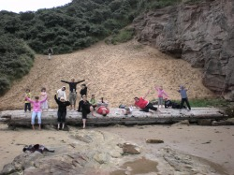 | What a fantastic and fun packed summer we have had. We have just had the best time ever, and i am sure all the children will agree there has never been a dull moment. We have done so many activities over the past 7 weeks, and i get exhausted just thinking about it, we have done sports, crafts, baking, risk and challenege, singing, dancing, street and creative dance, kite making, waters fights, BBQ'S and picinics, trips to the park, tarzan and den building, river walking, as well as enjoying trips to the cinema and ten pin bowling, and our amazing trip to the beach, and in the children's words, "this trip has just been the best, 10 out of ten"
At the beach the children had a ball exploring rocks and rock pools, paddling in the sea, treasure hunts, team games and races, collecting craft materials, bbq's, and toasting marshmallows. The day couldn't have went any better, and Mr Sunshine even had his hat on.
All the pictures from the summer club are now online, so please have a look, they are fab!!
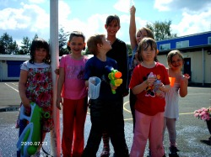
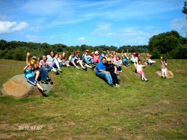 | We have welcomed some new faces over the summer, and more now the new term has started, its great to see everyone again, We are planning on having another great year, which I am sure all old and new children will have a great time, and not want to go home at the end of the night.  During the summer months we had our Care Commission inspection, which i am delighted to report went Fantastic, this report will be in the club for people to see, and also on the care commissions website which is www.carecommission.com .
We have also welcomed another member of staff onboard to join our existing team, Lesley has joined us on a Temporary contract, but hopefully if our expansion goes ahead, this will be permanent. Some parent's may already have seen Lesley in the club, as she has helped us out in the past, please introduce yourself to her, and like wise i will be introducing Lesley.
Here's to the next year, we hope you all enjoy your time at the Little Villagers, and our aim is to send the children home with a huge smile.
Nikki

