Club update
There has been a few staff changes in the club over the last month, we have introduced 3 new members of staff, Karen Wilkinson, Cheryl Devaney and John Francis, and also said goodbye to Fiona who is now over in the U.S.A doing camp America. Fiona will return to the club during holiday clubs, so everyone will see her again.
Our new staff members have all settled in well, because there was such a change we have let the children and new staff get to know each other before introducing everyone to the parents, please feel free to introduce yourselves to them and like wise they will introduce themselves to you.

Summer Holiday club
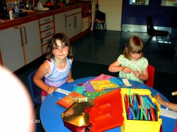
The summer holidays are well underway, and what an exciting summer we have planned for you all. We will be doing a wide variety of activities from Baking to B.B.QS, River walking to rambling in the woods. We also have arts and crafts, pizza making, trips to the cinema, ten pin bowling and the beach, sports and sports coaching, puppet making, kite making, tarzan building, den builiding, making a wig wam, outdoor crafts, its a knock out and the highland games, aswell as walks and picinics, trips to the park, lots of risk and challenge activities and also water play. This is only to name but a few. So i am sure your child/children will be entertained throughout the summer time, and will have lots of stories to tell you about their adventures.

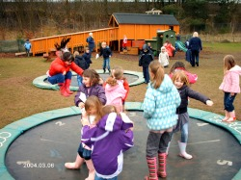
Throughout the summer time can you please ensure your child had the following items with them at all times, these can be left in the club over the summer time. Each child should have Suncream, Sunhats, and a change of clothes, just incase we have a wee sneaky water fight to cool down.
We have also asked the children to create an outdoor equipment wish list, we have purchased a trampoline like the children requested, which will stay up throughout the summer holiday, the other equipment requested will be purchased as soon as possible.
We all hope you enjoy your time with us over the summer, and look forward to meeting all the new faces in the new term.

